(Approx. 904 words)

Kretchmar’s Korner
Printer Problems
By David Kretchmar, Computer Hardware Technician, Sun City Summerlin Computer Club, NV
January 2019 issue, The Gigabyte Gazette
www.scscc.club/Tomburt89134 (at) cox.net

Printers are the most problematic piece of computer equipment, next to the computers themselves. Just like computers, you can’t live with them and you can’t live without them. Even if you’ve decided you can live without a full computer and have moved to a tablet or maybe just your smartphone, there are still going to be occasions when you want to have a “hard copy” (printed copy) of a document. Also, with the multi-functionality of most printers today, most of us have gotten used to the convenience of having a photocopier, scanner, and maybe even a FAX machine in our homes.
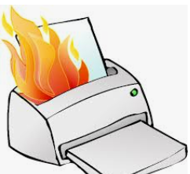
It’s easy to understand why printers are such a pain; there are so many moving parts and opportunities for something to go wrong. Fortunately, you can address many printer problems using the techniques I’m going to describe. If none of the following work, it is probably time to bite the bullet and invest in a new printer. If something mechanical is shot in a printer, the fix is often prohibitively expensive (just buying some new printer heads can cost over $100).

The USB connection
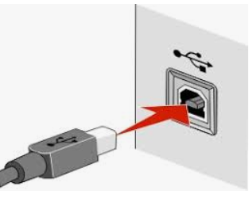
Unless you’re using a printer wirelessly, you need a working USB connection between your computer and your printer. Sometimes a wireless connection is necessary, such as when printing from a cell phone, tablet, or from a computer not proximate to the printer. But if you are printing from a computer adjacent to the printer, a wired USB connection is always more reliable and highly recommended. Most of us know how to connect the standard USB male connector to our computer, but there is more confusion with the other end of that USB cable that attaches into (usually) the back of the printer (see the picture to the left).
Unfortunately, the printer end of the USB cable also fits into the similar looking telephone line connection on the printer. Usually there is a pair of these female telephone line connectors on printers that include FAX capability; at least one will often be covered with a plastic cap.
One way to tell if you are using the USB connection on the printer is to listen for the USB “handshake” tone from the computer. If both your printer and computer are on, you should hear a couple of notes then you plug in or remove a USB device. If not, most likely you have missed that USB connection on the printer. Be especially aware of this possibility if you are setting up a printer new to your system, or if for some reason the cable has become disconnected from your printer. It is rare for the USB cable to go bad, but I have seen this on occasion.

Drivers can drive you crazy
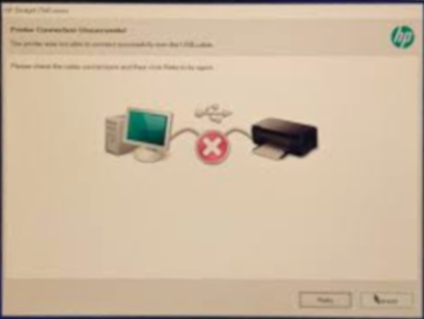
The printer and the computer must be able to communicate with each other, and this is accomplished with specialized software known as drivers. Windows 10 has printing drivers for most of the newer printers available today, but I strongly suggest installing the drivers furnished by the computer’s manufacturer. This is especially true if you want to do more than print, i.e. if you want to scan a document into a file. A new printer will usually come with a CD that can be used to load the drivers appropriate for your operating system. If you have a tablet or other device that does not include an optical drive you can go the printer manufacturer’s website, i.e. hp.com/support, and download and install the appropriate drivers. If you have a choice between downloading the basic or full featured software package, I suggest downloading the full featured package then doing a custom install, installing only the software you will be using. For whatever reason the full featured software package sometimes works when the basic package does not.
Manufacturers will often keep their website drivers more up to date, fixing bugs that have appeared after the printer has been on the market for a while. So, if you are having issues with your printer it’s a good idea to download drivers from their website.
When you do the custom install of your printer software, I suggest you deselect features such as the customer participation programs and supply ordering programs. I would also pass on the free optical character recognition (OCR) program, unless this is something you will use. OCR programs can be a real resource hog.
After the driver installation and a reboot see if any new programs are loading automatically by seeing if there are any new icons appearing on the right side of your taskbar. If so, you might want to open MSCONFIG and stop these programs from loading on startup. If you get a popup asking if you want low ink notifications immediately or “only when printing”, select “only when printing”, so this program will not be running constantly.
If you are buying a printer to use with a wireless device such as a Kindle Fire, Smartphone or iPad, do some research and make sure you are getting a printer that is supported by your device.
As you might expect with the popularity of the iPad, many printers will support the iPad with a free download from Apple. I’ve noticed that especially newer Hewlett Packard wireless printers are made to be compatible with the iPad.

